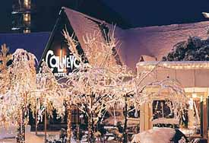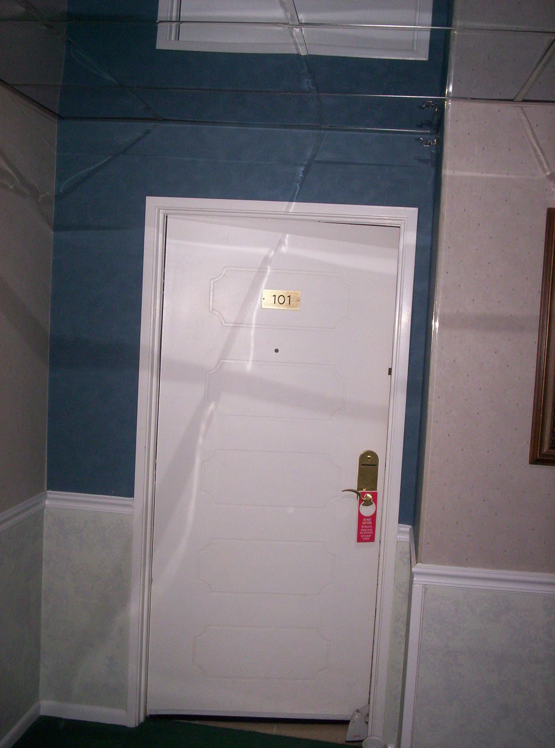

All I wanted to do for my birthday in 2007 was spend the night in the supposed haunted room (Room 101) of the Cal-Neva Casino on the north shore of Lake Tahoe (we’re on the south shore). As a skeptic, I wanted to do something most people would not dare to do.
I thought a one-night getaway (without kids!), still in a gorgeous location, would be a nice treat.

But even though I was a total non-believer, I would not have gone alone.
I may be a skeptic, but I am, of course, an open-minded one!

There are many employees of the Cal-Neva who won’t even go anywhere on the first floor of the hotel at all, let alone near the end of the hallway where Room 101 is located. It’s always the very last room rented. Some people have come running out in the middle of the night screaming that they had to have another room right then and there!
When we told people we were staying in that room – asked for it specifically – we were met with reactions ranging from horrified to enthralled.

I thought going there as a team of me, total skeptic, and my friend Melodie, far more spiritual and receptive, would make the perfect combination. Apart from the more otherwordly experiences, just the history of the place was amazing. Once owned by Sinatra and the mob, it’s also the oldest continuously-operating casino in all of Nevada (before Las Vegas) and, of course, America as a whole.
I had always taken tourists who come to visit us up there (it’s directly across the lake from us on the north side; you can actually just make out its 9-story tower when you look across the lake from where we are) because it straddles the California-Nevada state line.
In their big function room, they have a thick line: half silver (Nevada is the “Silver State”) and half gold (for California, the “Gold State”) transvering the entire room.
They also have the stateline transversing their pool:

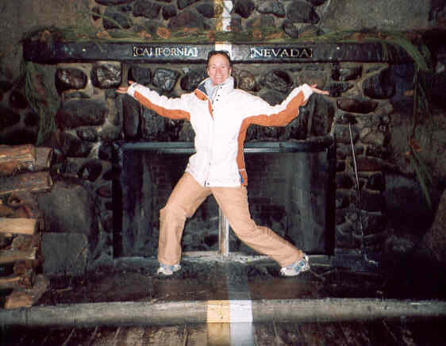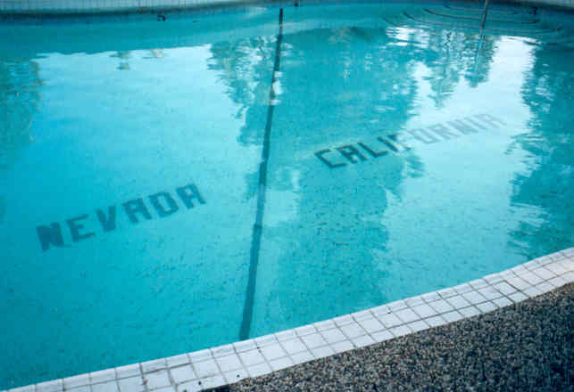

Now, even though I was a skeptic, I’ve seen enough movies and TV shows to know that if there are such things as ghosts or spirits, you can’t usually see or hear them in real life or real time. But they will show up on photographs and/or tape recordings.

So we took a lot of photographs of us two in the room, and just parts of the room by themselves, and I also brought along my handheld dictation tape machine.

The story behind the room, according to what our tour guide told us personally, is that the casino’s cocktail lounge piano player killed himself in 1997 with pills and a bag over his head when he learned he had AIDS.
Although I have read a different version in various newspaper articles talking about the bizarre occurrences at the Cal-Neva, where they say an employee hung himself in the room upon learning he had terminal cancer. (Although I really couldn’t see any place within the room where someone could have hung themselves - there was nothing high enough up... i.e. there was no overhead light fixture, only lamps, and the shower rod, not only not strong enough... just not high enough...)

So, trusting our tour guide more than newspaper articles, as we are drifting off to sleep (this was about 1:00 a.m.), we were asking questions and left the tape running (each side: 30 minutes until it shuts off automatically)

Of the approximately 2 hours we recorded, there are strange noises we can’t attribute to anything and possible unknown voices, but we are disregarding those for the sake of fairness.
HOWEVER!!
Soon after we turned on the tape after settling in, I asked, “Do you regret doing what you did?” My voice is somewhat distant as I am on the bed in the middle of the room and the recorder is on the little table by the window.
There is a 2-3 second pause. And then BOOMING – as if right there up on top of the microphone – a definite male voice answers in a very loud rustling whisper, “Oh man, oh!”
Melodie then asks (also distant from the middle of the room): “Are you grateful to the old man for letting you stay in this room?”
And then a very distinct, male: “No!”

(The story being that after the (former) owner of the hotel/casino found out about the guy’s disease, he felt so bad for him because the guy had nowhere to go, and the owner was supposedly a very nice man to begin with, that he let him stay in this room for free.)

Keep in mind that we just threw these questions out into the night as we were drifting off to sleep. We never heard any response.
It was only the next morning as we listened back to what we had recorded.....
The first time we listened, I was holding the recorder, and I threw it down on the bed,
did not even want to touch it, it shook me so much.

Now, I realize that it is a very fair assumption that no one could be expected to believe us. After all, for all they know, we could have had a man in the room with us to do that as a practical joke. But the two of us know exactly what the layout and situation was.
Room 101 isn't even near another room and even though it's called the “first” floor, it’s technically one floor up from the ground (i.e. 15 foot drop or so to the ground below) and there is no balcony - i.e. no one could be standing outside talking in through the window).
We had actually turned off the heater that night (and it was very cold that night) because our earlier recordings had picked up the heater kicking on and off as loud and annoying).

So there is no way anyone could convince me this wasn’t something... unexplainable.

And the photographs... of all the photos I took elsewhere in the hotel and on the tunnel/ghost tour they offer, they all came out normal. Nothing out of the ordinary at all.

But the 41 pictures I took in the room - what people who believe in this sort of stuff call “orbs” and claim they are spiritual energy of spirits. They are ALL OVER our photos from Room 101. They are always in different places - at first I thought they might be dust or water drops on my camera lens but they are always in different places, of different sizes, different degrees of transparency, etc. They are simply not explainable.

Also, Melodie claims that she was woken up sometime in the middle of the night because she heard me mucking about in the bathroom. She thought it sounded like I was going to be sick. (I should explain Room 101 is actually a handicapped room and there is no door to the bathroom. So sounds carry out to the room part much clearer) Because there’s no door, she felt like she wanted to give me as much privacy as possible under such circumstances, so she didn’t say anything at first. But then she started worrying that I was going to hurt myself because it obviously sounded to her like I didn’t know my way around an unfamiliar bathroom in the dark - that I was groping around awkwardly and I might hit my head on the sink or the toilet, etc. So she finally called out: “Hey, are you okay in there?”
And then she looked over and saw me sleeping peacefully in the bed.

I berated her over and over the next morning about why she didn’t wake me up.
She said she was too scared to even consider moving.
How she even went back to sleep, I’ll never know.

Even now, I am still not sure what I believe about what we experienced that night.
It was definitely something... but what exactly... I don't know that I'll ever be able to pinpoint it.
I do know that Melodie and I will return to stay another night sometime soon.

Meanwhile, just in case you want to read up some more on the Cal-Neva yourself,
this is the hotel’s own website.

Then this newspaper article entitled “Legends of the lake and beyond” as published on 1/5/2007 in the Tahoe Daily Tribune down here on the south shore. I found this article while googling for something else entirely... and was hooked from that point on!

Then there's this article entitled “A Night at the Cal Neva” published in “Tahoe World” on 12/6/2006.
This is a website called “Janice Oberding's Haunted Nevada” - has pictures of Cabin 3 (what used to be Marilyn Monroe’s and was the site of her near-death just one week before her actual death down in LA; some also claim this cabin is now haunted for that reason) and an underground hallway (as seen when you take their tour).

And this is the written version (11/7/07) of the Bill Brown/KTVN Channel 2-CBS Reno news story aired on “Haunted Nevada: Cal-Neva Resort and Casino” - contains links to two videos that ran as segments on their newscast. The first one includes supposed audio from Marilyn’s cabin and the second one includes audio from Room 101 - although I can tell you right now that our audio, while just as short, is far more clearer! Wow!

