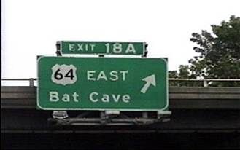

Just in case Batman forgets?

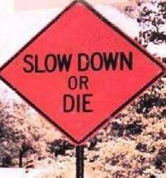

Hmmm…. decisions… decisions….

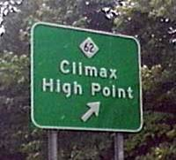

Well, thank goodness!!! Up until now, only 36% of women have been able to find this.

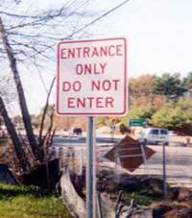

So just what would we do at the exit?

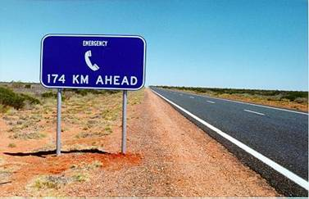

For the more non-urgent emergencies

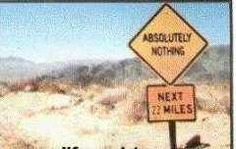

Geez, not even a non-urgent emergency phone?

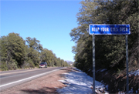

Helpful driving advice
{“KEEP YOUR EYES OPEN”}

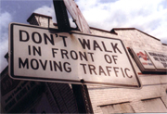

Even more helpful

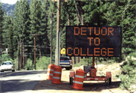

A spelling-while-driving test. Simply pull off the road, note the error, and you’re eligible to pay $30,000 a year for a liberal arts education.
Photo Location: Incline Village, NV {north shore of Lake Tahoe}

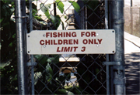

Good thing there’s a catch limit.
Possible location: Neverland



For here or to go?

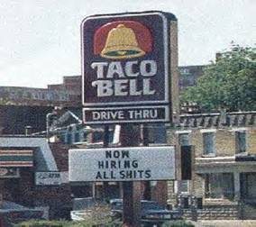

And you thought that particular personality trait wouldn't look good on your resume...



Hygiene is important.

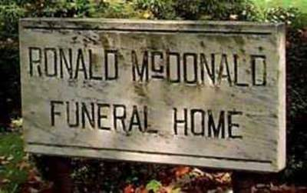

McDeath

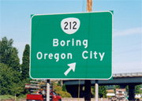

Early Warning System

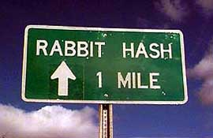

To calm those stressed rabbits.

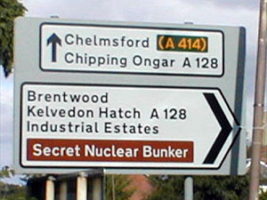

Oops, not so secret any more!

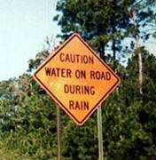
Another fine example of rocket science.

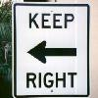

No! The other right!!

HOW cold is it??

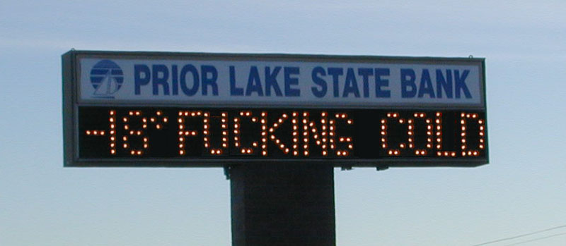

And if that’s not a good enough weather forecaster for you, try Gary’s super-duper never-fails Weather Forecasting Stone:

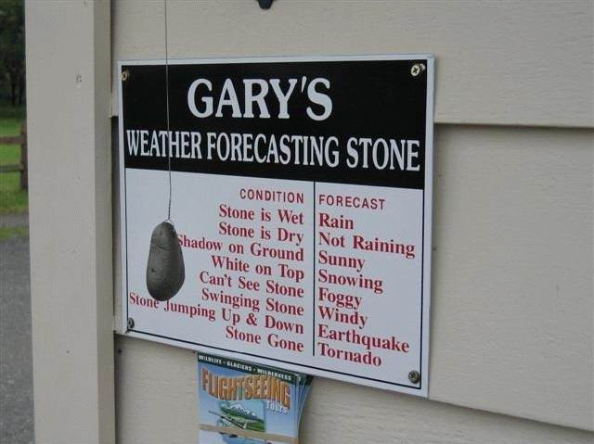



How the Hungarians show they love their tourists.

My own two personal favorites:

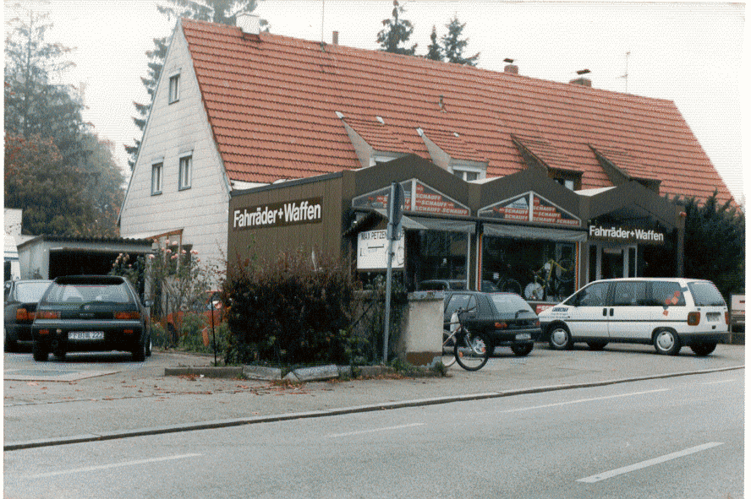

Taking road rage to the extreme.
[ Fahrräder = bicycles / Waffen = weapons ]

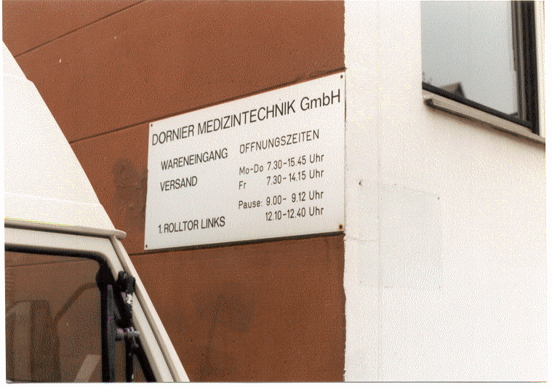

Gotta love those clockwork Germans
[ Pause = break, as in coffee break: 9:00 - 9:12 a.m. ]

Except for the last two photos, which are mine, most of these and many, many more can be found in Doug Lansky’s Signspotting book, published by Lonely Planet

